Associate Exit Flow

*(Associate Exit Flow – Guide)*

This document describes in detail the **Associate Exit Flow**. This portal has different user roles like (*Associate, Program Manager, HRM- Human Resource Manager, HRA, Team Lead, Manager-IT department, Manager-Admin department, Manager-Finance department, Manager-Training department).*

1. **Corporate**
2. Once HRM approves the resignation. Corporate can give Exit interview feedback.
3. Corporate needs to login to the portal (Via single sign-on) with SenecaGlobal email Id. After authentication, HRA will be redirected to the Dashboard page. They need to click on Associate Exit section and Exit-Action module to view “Pending Request”.
4. Click on ‘**Associate details’** having the status as ‘**Resignation In Progress’**
5. Clicking on ‘**Exit Interview’** Button navigates to the ‘**Associate Exit Interview’** screen

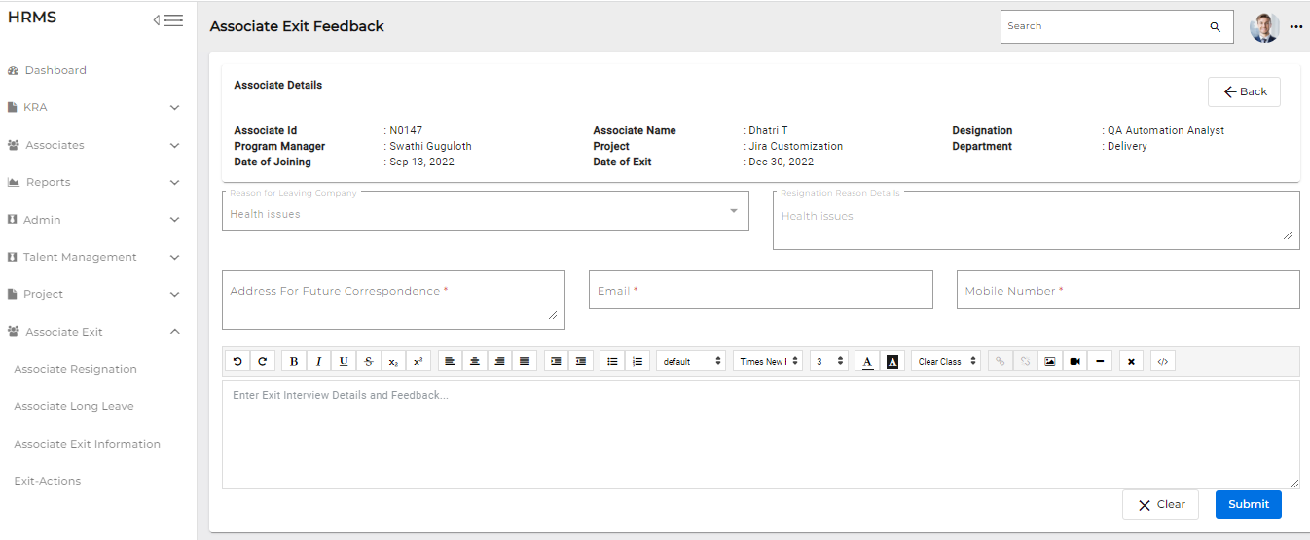

1. Corporate lead enters the associate address for future correspondence, email address and mobile number

* **Clicking on the submit button after Exit interview is done, Email triggers to Program Manager, HRM status changes status to ‘Exit interview completed’**